Question 1
Chapter 21 focuses on A) 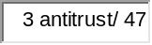 legislation and policy. The term stems from the fact that as business firms grew larger as a result of widening markets after the Civil War, some combined into a single decision group known as a B) 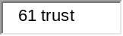. This term, therefore, became associated with a market model that we have already analyzed, C) 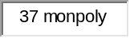. In the purest sense, this market model means a D) 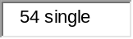 seller. However, it has evolved to be interpreted by the public and the government as a E) 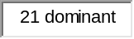 seller in an industry.

Question 2
The antitrust case that established the Rule of Reason was the A)B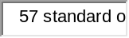 case of B) 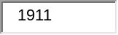 (enter year). The Rule of Reason established the legal precedent that C) 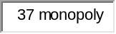, alone, was not an offense. The term per se means D) 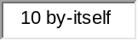. The Per Se Rule, in the context of antitrust legislation, refers to the fact that E) 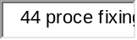 and F) 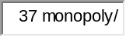 are illegal, per se, and therefore not subject to the G) 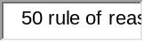. Two cases where the defendants were convicted of per se violations are: H) 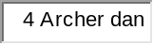, in 1996, and I) 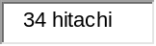 in 2007.

Question 3
The cornerstone of antitrust policy in the United States is the A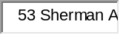 of B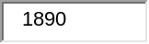 (enter year). However, this act was rather vague and ambiguous and required a more explicit statement of what their boundaries were. As a result, Congress passed the C) 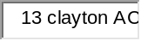 of D) 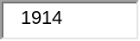 (enter year) for this purpose. This law explicitly made four specific acts illegal:
E) 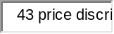 -- when it is not justified by cost differences.
F) 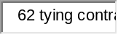 -- when a resource supplier requires that it's customer purchase another item, as well.
G) 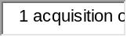 -- when the outcome would be reduced competition within the industry H) 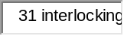 -- when the effect would be to reduce competition.
11.3 points

Question 4
One intent of the act referred to in Question 3 was to prevent potentially anti-competitive A) 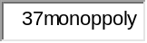 through the purchase of a competing company's B) 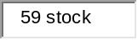. However, firms found a loop-hole by simply acquiring a competing firms C) 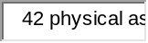. To close this loop-hole, Congress passed the D) 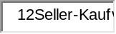 of E) 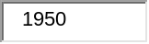 (enter year).

Question 5
The A) 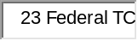 was established in B (enter year). Along with the Department of Justice, this federal agency has the joint responsibility of enforcing the nation's antitrust laws. In addition to these two Executive Branch entities, antitrust suits can be filed by C) 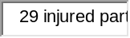 or D) 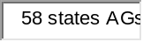. One responsibility is to protect the public against false or misleading E) 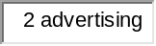. This task was assigned to it by the F) 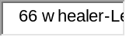 Act of G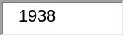 (enter year).

Question 6
One problem that courts have in determining whether a firm has A)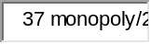 power or not is in defining the B) 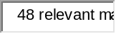. In the Alcoa case of C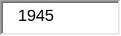 (enter year), for example, the Supreme Court used a very D) 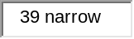 definition when it ruled that Alcoa was a E) 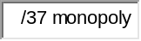 because it held 90% of the aluminum ingot market, and thus found guilty of violating the F) 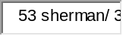. However, in the DuPont Cellophane case, the Supreme Court used a G) 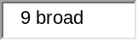 definition, accepting DuPont's argument that its market power should be considered, not in the context of the cellophane market in which it possessed 100%, but rather in the context of the H) 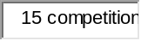 market, where it only controlled 20%. No sanctions were brought against DuPont because it was found not to have I) power in this market.

Question 7
Many utility companies are A)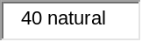 monopolies. Either public ownership or public B)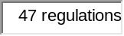 is the preferable option for dealing with such companies. With this option, the pricing policy would permit the firm to earn a C)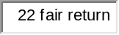 on the value of its assets. The problem, however, is that such an arrangement might lower the incentive for the firm to reduce its D)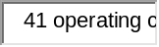 because they would be permitted to pass any increases on to their customers in the form of higher E)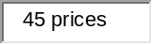. The customer would be powerless because the firm is a F) and consumers have no alternative source of supply. Another problem is illustrated by the regulation of the railroads by the G)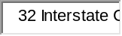. Although in the 1930's, H) with the railroads began to emerge from the trucking industry, making these regulations obsolete. Nevertheless, the regulations remained in place until the regulating agency was abolished in I)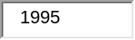 (enter year).

Question 8 t
In 1998, the Department of Justice brought charges against Microsoft Corp., claiming that it was in violation of the A). The case is important because the initial B)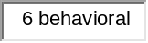 remedy, such as that imposed on C)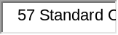 in 1911 and on D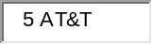 in 1982, was replaced with a E)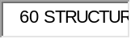 remedy.

Question 9
There are three basic categories of mergers:
The A)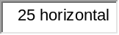 merger is the combining of two competitors in the B 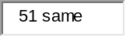 industry. Such a merger is potentially anti-competitive because it C 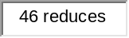 the number of competing firms in the industry and D)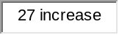 the market power of one of the firms. The E)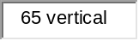 merger is the combining of a producer of a good with a resource supplier. Such a merger is potentially anti-competitive because it would allow one company to determine F 6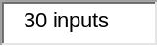 prices for its direct competitor. The G)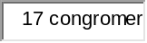 merger is, essentially, a combination of firms in H) industries. This type of merger is the I)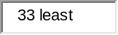 likely of the three to reduce competition or evoke antitrust actions by the government.

Question 10
According to economists, a regulation should be imposed if the marginal A)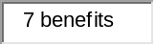 of the regulation exceeds its marginal B)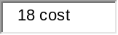. The problem that both economists and policy maker have is that it's difficult to C)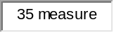 these values. As a result, D)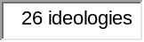 often drives the debate more than economic E analysis.

